**CURRICULUM VITAE**

**PERSONAL INFORMATION**

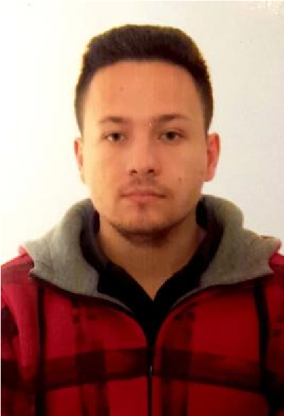

Name, Surname Atif Halitović

Adress(es) Aleja zlatnih ljiljana 19,

Bosanska Krupa 77240

Bosnia and Herzegovina

Phone +38761230456

|  |  |  |
| --- | --- | --- |
| Email |  | atifhalitovic@gmail.com |
| Date of birth |  | 08.09.1995. |
| Place of birth |  | Bihać |
| Field of Application    **EDUCATION** |  | Application for the job |
| 10/2016- |  | **[Faculty of Information Technologies, Dzemal Bijedic University**  **Mostar, Sjeverni logor bb, 88000 Mostar (Bosnia and**  **Herzegovina) ]**  Bachelor degree of Information Technologies |
| 2/2018-7/2018 |  | **[NOVA Information Management School, Universidade NOVA de Lisboa, Campus de Campolide 1070-312 Lisbon (Portugal)**  Erasmus student exchange mobility programme – 4th semester Bachelor degree of Information Systems |
| 2/2019-7/2019  **PERSONAL SKILLS** |  | **[Silesian University of Technology, Faculty of Automatic Control, Electronics and Computer Science, Akademicka 16 St., 44-100 Gliwice (Poland)]**  Erasmus student exchange mobility programme – 6th semester  Bachelor degree of Interdisciplinary studies of Automatics, Robotics, Electronics, Telecommunications and IT |
| Mother tongue(s) |  | Bosnian |

|  |  |  |  |  |
| --- | --- | --- | --- | --- |
| UNDERSTANDING | | SPEAKING | | WRITING |
| Listening | Reading | Spoken  Interaction | Spoken production |  |
| **B2** | **B2** | **B2** | **B2** | **C1** |
| **A1** | **A1** | **A1** | **A1** | **A1** |

Other language(s)

English

German

Levels A1/A2: Basic user – B1/B2: Independent user – C1/C2: Proficient User

[Common European Framework of Reference for Languages](http://europass.cedefop.europa.eu/resources/european-language-levels-cefr)

Computer skills and - Good experience in the C/C++ programming language

competences - Experience in use of HTML/CSS/JS languages

* Experience with Microsoft SQL Management Studio
* Beginner in C#, ASP.core development
* Business intelligence projects
* Some experience in project managementing during my exchange in

Lisbon, working on various school projects in Project for Information

Systems course

* Microsoft office package
* PowerDesigner (system analysis)
* Photoshop
* Attendance at couple of IT related conferences and workshops; SCRUM, Agile, Software development cycles

Key Qualifications - Good communication and presenting skills gained through participating in various college projects

* Like to work in team and learn from more experienced members than me

Driving licence B

Hobbies Photography, videography